Json notes

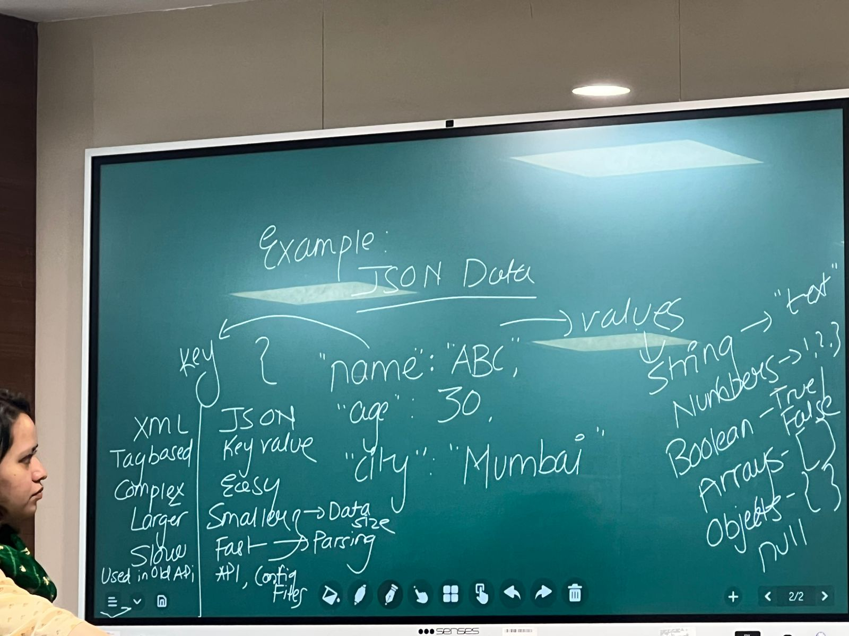

This is for retriving the data

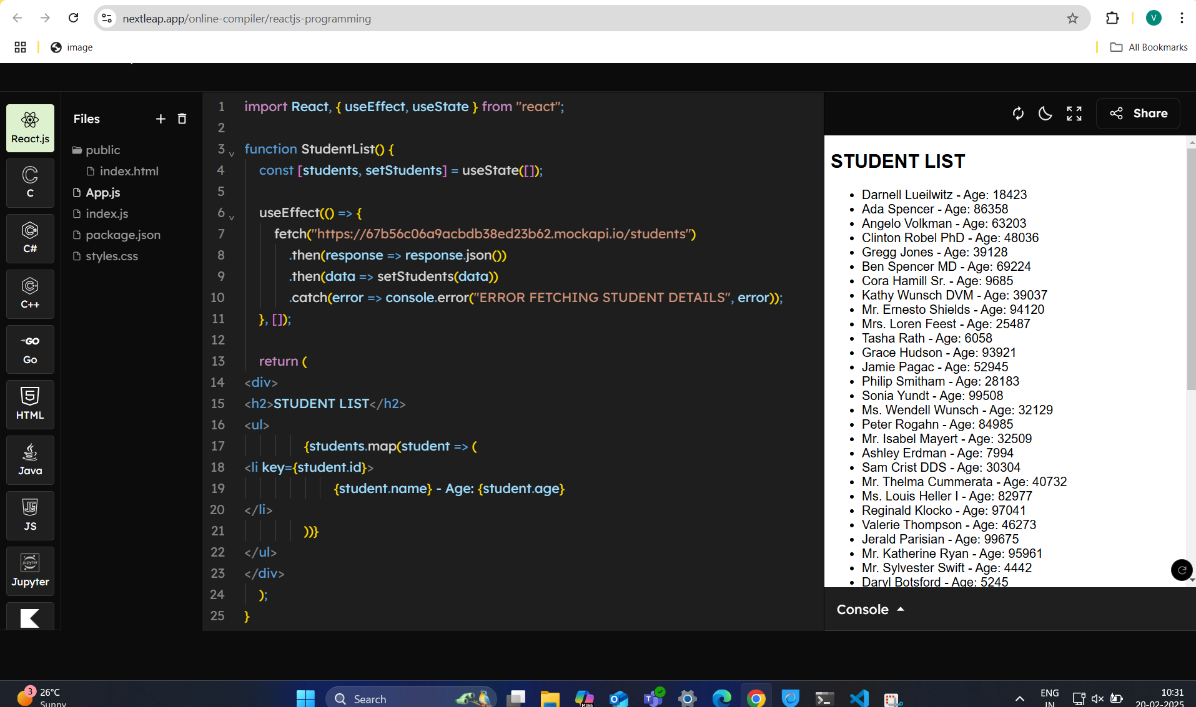

import React, { useEffect, useState } from "react";

function StudentList() {

    const [students, setStudents] = useState([]);

    useEffect(() => {

        fetch("https://67b56c06a9acbdb38ed23b62.mockapi.io/students")

            .then(*response* => *response*.json())

            .then(*data* => setStudents(*data*))

            .catch(*error* => console.error("ERROR FETCHING STUDENT DETAILS", *error*));

    }, []);

    return (

<div>

<h2>STUDENT LIST</h2>

<ul>  {*students*.*map*(*student* => (

<li key={student.id}>

{*student*.*name*} - *Age*: {student.age}

</li>

                ))}

</ul>

</div>

    );

}

export default StudentList;

send data using post

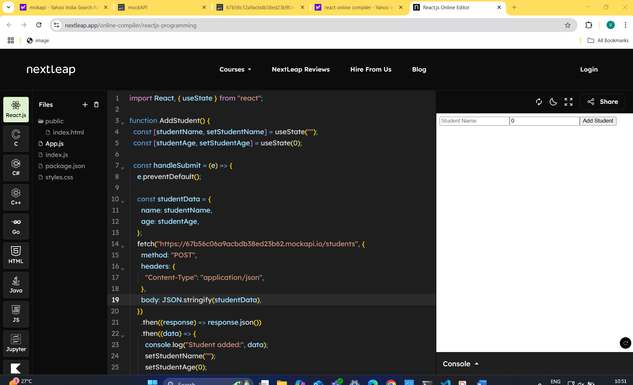

import React, { useState } from "react";

function AddStudent() {

  const [studentName, setStudentName] = useState("");

  const [studentAge, setStudentAge] = useState(0);

  const handleSubmit = (*e*) => {

    e.preventDefault();

    const studentData = {

      name: studentName,

      age: studentAge,

    };

    fetch("https://67b56c06a9acbdb38ed23b62.mockapi.io/students", {

      method: "POST",

      headers: {

        "Content-Type": "application/json",

      },

      body: JSON.stringify(studentData),

    })

      .then((*response*) => response.json())

      .then((*data*) => {

        console.log("Student added:", data);

        setStudentName("");

        setStudentAge(0);

      })

      .catch((*error*) => {

        console.error("Error:", error);

      });

  };

 return (

<form *onSubmit*={handleSubmit}>

<input *type*="text" *placeholder*="Student Name" *value*={studentName}

*onChange*={(*e*) => setStudentName(e.target.value)}

*required*

      />

<input *type*="number" *placeholder*="Student Age" *value*={studentAge}

*onChange*={(*e*) => setStudentAge(e.target.value)}

*required*

      />

<button *type*="submit">Add Student</button>

</form>

  );

}

export default AddStudent;

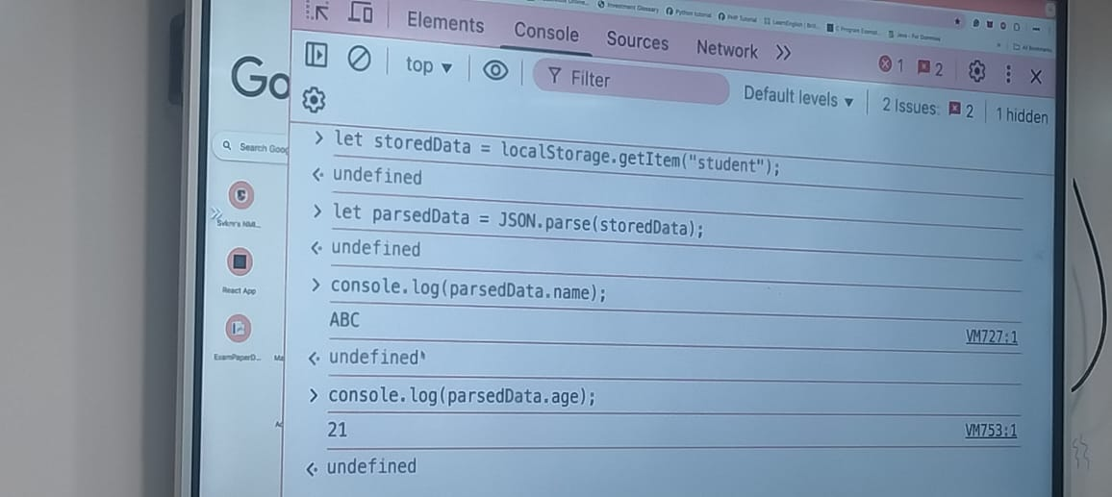

**console commands**

let student={name:"KAVIA",age:21};

localStorage.setItem("student",JSON.stringify(student));

let storedData=localStorage.getItem("student");

console.log(parseData.name);

console.log(parseData.age);

let students=JSON.parse(localStorage.getitem(“student”))||[];

student.push({name:”Anjily2”,age:23});

localStorage.setItem(“students”,JSON.stringfy(student));

console.log(localStorage.getItem(“students”));

localstorage.removeItem(“students”));

**remove single value**

**students= students.filter(student=>student.name!==”Anjili”);**